 | Student Name ___MARKING KEY______  Eastern Goldfields College  Mathematics Essentials 2015  Mental Test 3
 | Time allowed: 10 minutes Total Marks: 504 marks
CALCULATORS AND FILES ARE NOT ALLOWED
(1)  1750 mL = ___1.75__ L ✓ | (2)  3.15 L = __3150__ mL ✓
(3) Estimate the capacity of the bottle on the front desk, using mL, L or kL. | (4) Estimate the capacity of the box on the front desk, using mL, L or kL.
(5) What is the volume of a rectangular box that is 15 cm by 2 cm by 100 cm?  3000 cm³ ✓ | (6) What is the capacity of the rectangular box in question 5?  3000 mL or 3 L ✓
(7)  3 cm³ = ____3000__ mm³ ✓ | (8)  3 kW = ___3000___ W ✓
(9) An LCD TV consumes 250 Watts per hour. If the TV is left on for 8 hours, how much energy is consumed?  2 000 W or 2 kW ✓ | (10) If an air-conditioner consumes 1600 Watts per hour, how long does it take for the air-conditioner to use 8 kW?  5 hrs ✓
(11) 1 teaspoon = 5 mL. How many teaspoons of medicine does John need, to take 85 mL?  17 ✓ | (12) 1 cal = 4.186 kJ. Estimate how many calories in 321 kJ.  80 cal ✓
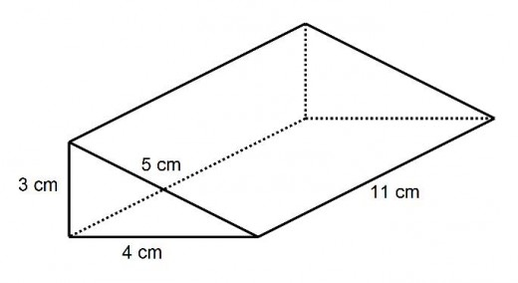 | (13) Calculate the volume of the triangular  prism, pictured left?  66 cm³ ✓  (14) What is the capacity of this triangular  prism, pictured left?  66 ml ✓

